INTRODUNCTION TO OSPF

Q1. Open Cisco Packet Tracer and create a simple network with three routers connected in a triangle topology using serial or Ethernet links.
Ans.
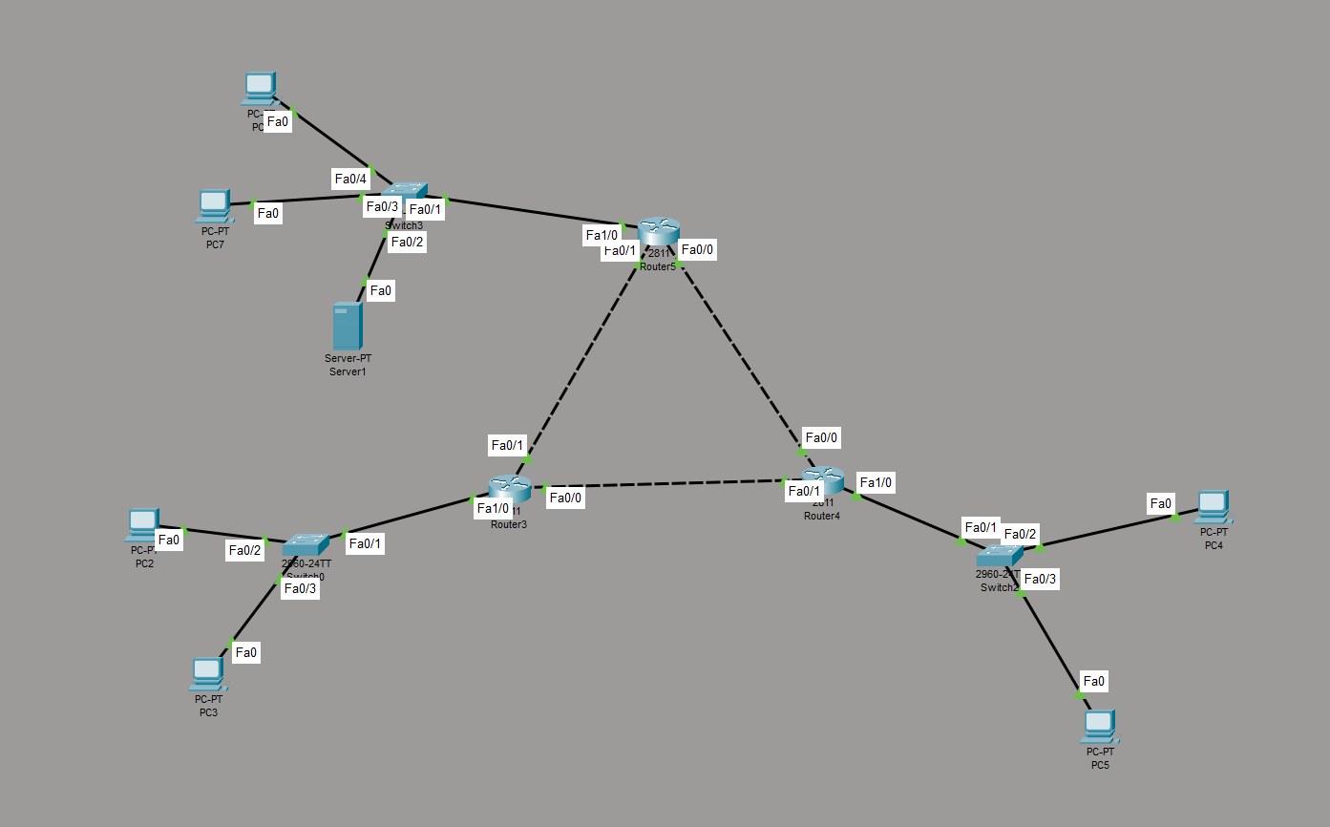
Q2. Assign IP addresses to all router interfaces in your Packet Tracer network and verify connectivity using the ping command.
Ans. I have assigned IP addresses to all router interface and used ping command to check
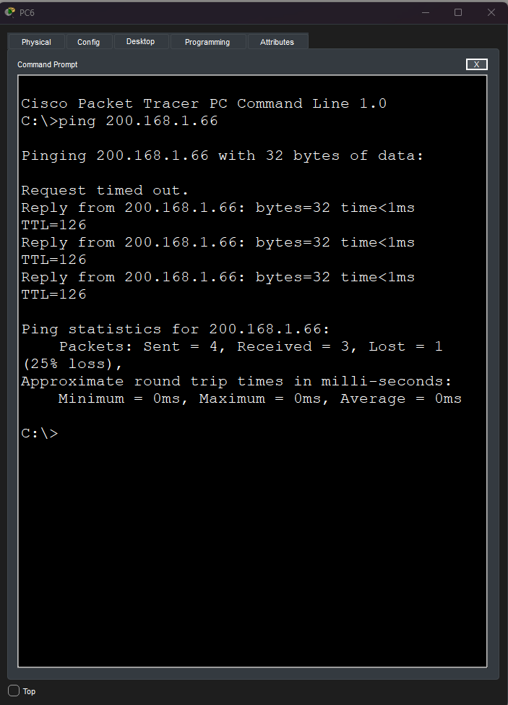
Q3. Configure OSPF on each router using the router ospf 1 command and the network command to advertise all directly connected networks.
Ans. In this topology I have configure ospf routing using ospf 1 command.
Q4. Observe and document the OSPF adjacency formation process by checking the output of the show ip ospf neighbor command on each router. Hint: Look for the FULL/DR or FULL/BDR state to confirm adjacency.
Ans. Step 1: Check OSPF Neighbors
Open the router CLI in Cisco Packet Tracer and enter:
Router> enable
Router# show ip ospf neighbor
Step 2: Observed Output
According to the provided screenshot:
Neighbor ID | Priority | State | IP Address | Interface
200.168.1.97 | 1 | FULL/DR | 200.168.1.9 | Fa0/1
200.168.1.65 | 1 | FULL/DR | 200.168.1.2 | Fa0/0
Step 3: Observation and Analysis
- The router has successfully detected two OSPF neighbors.
- Both neighbors are in the FULL/DR state, confirming successful OSPF adjacency.
- FULL indicates that the OSPF databases are synchronized.
- DR (Designated Router) indicates that each neighbor acts as the designated router on its respective network segment.
- The Dead Time is 39 seconds, indicating that the neighbor relationships are active.
Conclusion: The show ip ospf neighbor command confirms that both OSPF neighbors have successfully established adjacency. The FULL/DR state indicates that OSPF is functioning correctly and the routers can exchange routing information.
Q5. Change the OSPF cost on one interface using the ip ospf cost command and verify how it affects the OSPF routing table. Hint: Use show ip route ospf to see route changes after modifying the cost.
Ans. Step 1: Check the Current OSPF Routes
Open the router CLI in Cisco Packet Tracer and enter:
Router> enable
Router# show ip route ospf
This command displays the OSPF-learned routes and their current metric values.
Step 2: Change the OSPF Cost
Configure a new OSPF cost of 50 on interface FastEthernet0/1.
Router# configure terminal
Router(config)# interface fa0/1
Router(config-if)# ip ospf cost 50
Router(config-if)# exit
Router(config)# end
Step 3: Verify the New Cost
Enter the following commands:
Router# show ip ospf interface fa0/1
Router# show ip route ospf
The first command verifies the updated interface cost, while the second displays changes in OSPF routes.
Step 4: Observation and Analysis
- The OSPF cost of interface Fa0/1 was configured to 50.
- OSPF uses cost as a metric to select the best path.
- A lower-cost path is preferred over a higher-cost path.
- After changing the cost, OSPF recalculates the best routes.
- If an alternative path has a lower total cost, OSPF may select that path.

